1974 Tartan 34-C
For SALE, asking $13.9

Peter Coggins
732-530-1493
732-804-0633

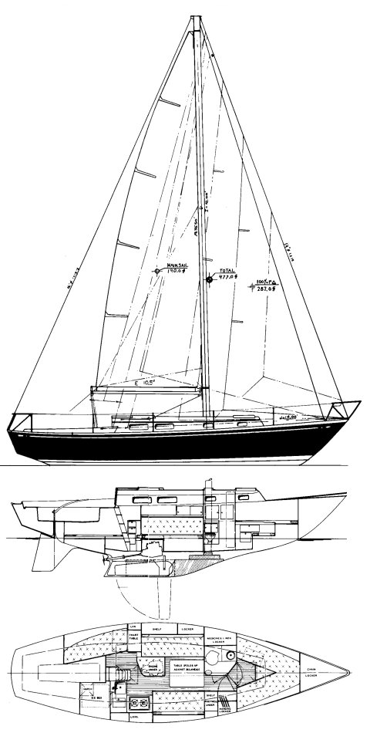

Hull Type: | Keel/Ctrbrd. |  | Rig Type: | Masthead Sloop
LOA: | 34.42' |  | LWL: | 25.00'
Beam: | 10.17' |  | Listed SA: | 527 ft²
Draft (max.) | 8.33' |  | Draft (min.) | 3.92'
Displacement: | 11,200 lbs. |  | Ballast: | 5000 lbs..
Designer: | Sparkman & Stephens
Builder: | Tartan Marine (USA)
Construction: | FG |  |  | Bal. type: | Lead
First Built: | 1968 | Last Built: | 1978 | # Built: | 525
AUXILIARY POWER (orig. equip.)
Make: | Universal |  | Model: | Atomic 4
Type: | Gas |  | HP: | 30
TANKS
Water: | 36 gals.. |  | Fuel: | 26 gals.
- S&S Design No. 1904. The letter "C" has been adopted on the used boat market, "classic", identifying it as the first 34 from Tartan. The second TARTAN 34, significantly different, which is also an S&S design, is commonly referred to as the TARTAN 34-2.
- The foot of the mainsail was shortened from the original design at least twice to improve balance and/or to lower its IOR rating.
Hull 125 and later: E = 12.0'; Hull 200 and later: E = 10.5' (displayed here)

HIN: TAR343130474
2019 NJ Registration: [NJ 2036 HJ]
Title: New Jersey

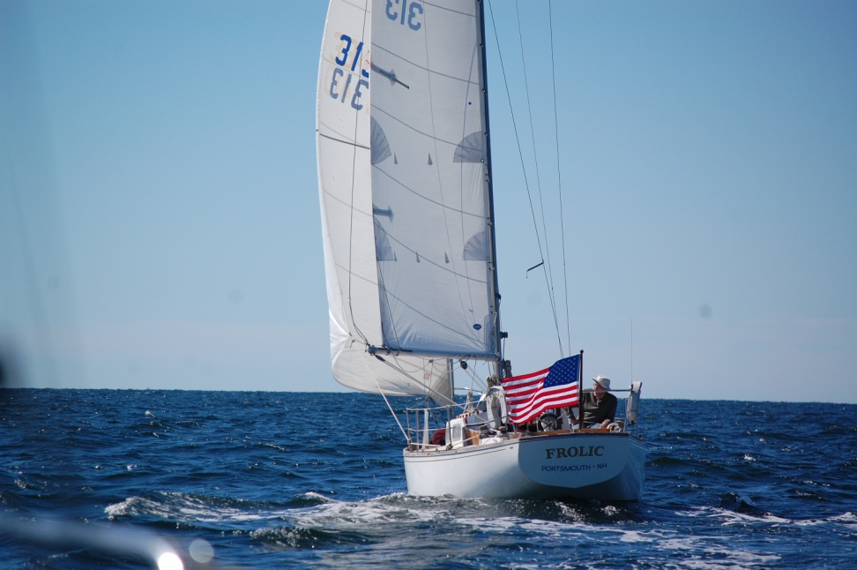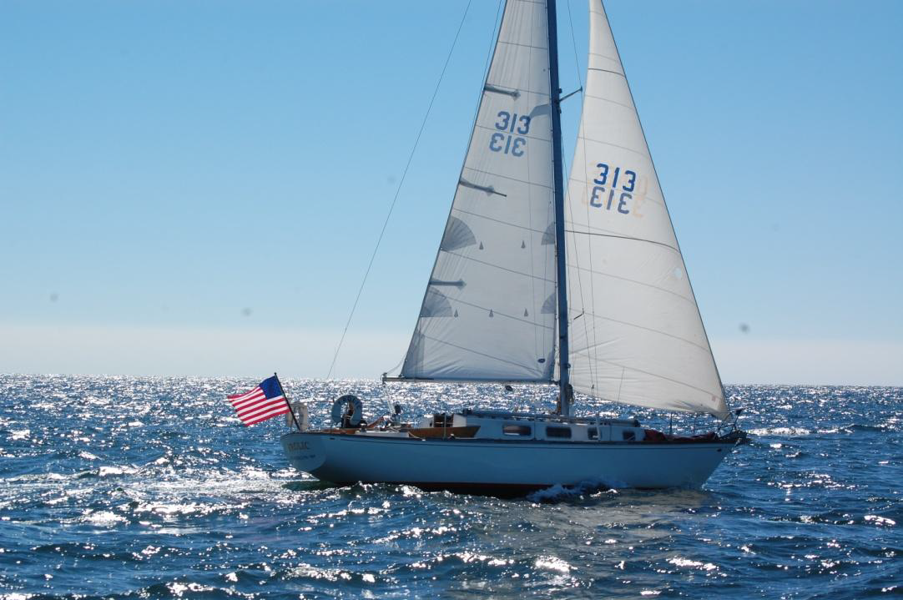
Heading South with a 15-18 kt West wind – (note, no big waves)

GENERAL
- Built in 1974, hull number 313
- The interior has had significant custom teak cabinetry work and refinishing. There are no open cabinets/bays; all bays (main cabin, galley & head) are enclosed with varnished teak sliding doors.
- Exterior teak has been refinished (varnish).
- The interior cushions were replaced 2016 by Tim Paddock (Atlantic Highlands, NJ). They have extra thickness (4+”) with comfortable, medium-firm foam.
- White vinyl cockpit cushions (2005)
- All port-lights have been re-bedded (2016).
- The four-small port-lights are opening design (all with screens)
- New Jabsco Manual Head (2018).
- Aft quarter berth has an 18” opening port that opens into the cockpit (improves lighting & ventilation).
- Opening hatches (companionway, main cabin center, fore peak) have screens.
- Edson wheel steering cable replaced (2011).
- New drive shaft, cutlass and 3-blade prop (designed for the Atomic-4 in a T-34C) installed by Carriage House Marine - 2014).
- Engine is currently being replaced with an Atomic-4 from Moyer Marine … (fresh-water cooled)
- Pressure fresh water for galley & head
- ‘Wind Scoop’ for v-berth hatch
- Bottom has 3 barrier coats
ELECTRONICS
- ICOM IC-M422 VHF Radio (2010) with a mast-head and an aft rail mounted VHF antennas.
- Raytheon 398 GPS (2005) …swings into the companionway)
- New Ray Marine CV-100 Auto-Pilot …installed by Lockwood Boat Works – (2017).
- Depth sounder… transducer is mounted internally in a PVC well with mineral oil … no thru hull !

SAIL INVENTORY
- Main (1988)
- 150% RF genoa (1998)
- 155% racing genoa
- 125% high clew genoa (2005)
- 90% heavy jib (NEVER USED – still in the bag)
- Storm jib (never used – in the bag)
- Starcut spinnaker (very little use)
- (Tri-Radial spinnaker - 1998) *
- Hood multi-purpose spinnaker (????)
- 14 ft spinnaker pole
- Rigged for double genoa halyards (internal)
- Rigged for double spinnaker halyards (external)
- Heavy weather & light air genoa sheets
WINCHES
- 2 - Enkes #24 two-speed genoa-sheet winches (1996)
- 2 - Barient #20 single-speed spinnaker-sheet winches (original)
- 4 - Barient #10 mast & coach-roof winches (original)
ANCHORS
- BRUCE (25 lb)
- CQR (25 lb) with 75 ft 3/8”chain and 100 ft ½” nylon rode.
- 3/8” x 15’ chain with 75 ft ½” nylon anchor rode
- 100 ft (extra) ½” anchor rode

BINACLE COMPASS
- Ritchie Binnacle Mount

SUNBRELLA WINTER COVER (3-section)
- All zippers have been replaced … (Suggest having Tim Paddock in Atlantic Highlands do any future work… very high-quality work at a very fair price)!
PORTABLE ELECTRIC BILGE PUMP - RULE 2000 gph (automatic) (2003)
Double BATTERY CHARGER - (DYTEK - 1990)
115v/30 amp dockside power cable
DOCKLINES - 4 new 5/8” x 35 ft black braided nylon dock lines, and 4 older ½” 3-strand nylon dock lines --- all with 10 in eyes.
LIFELINES - double lifelines with gates
FENDERS - (4 ea. 10” x 24”) inflatable
PFDs - 2-new inflatable, 2-standard (racing), 6-standard (‘covers-the-law’)
DINGHY - 6 ft, lightweight, hard chine FG hull, with oars… newly painted exterior
=================================================================================
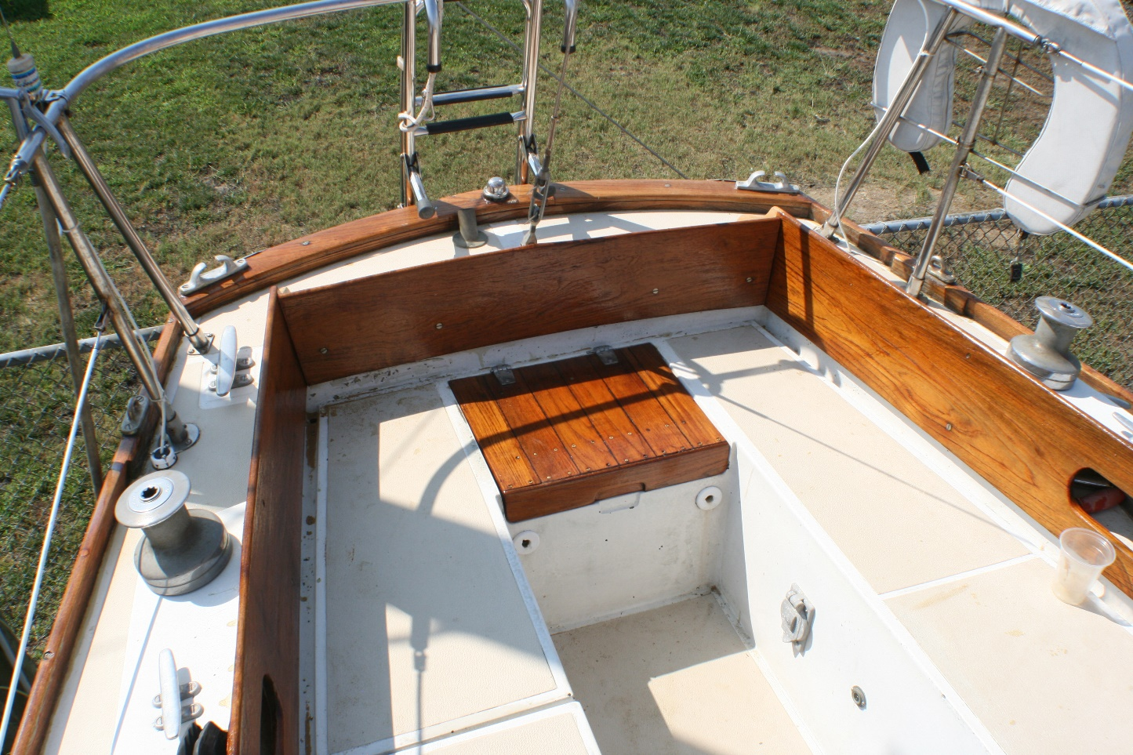
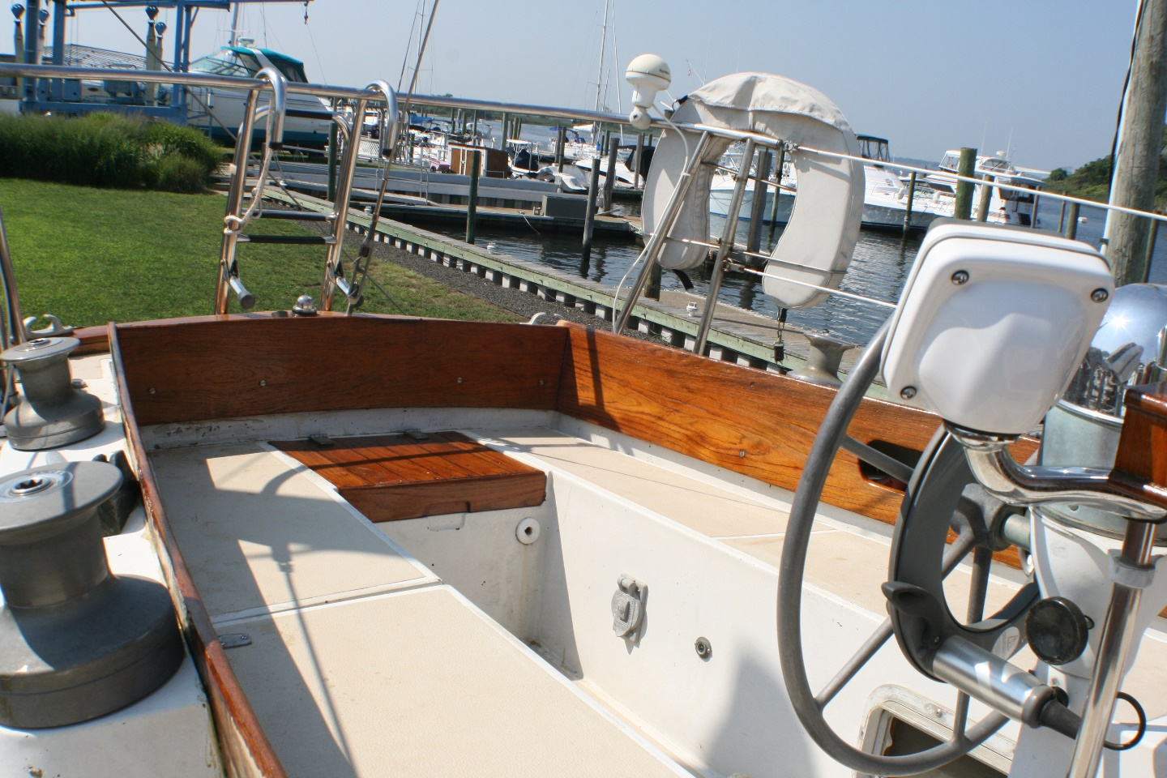

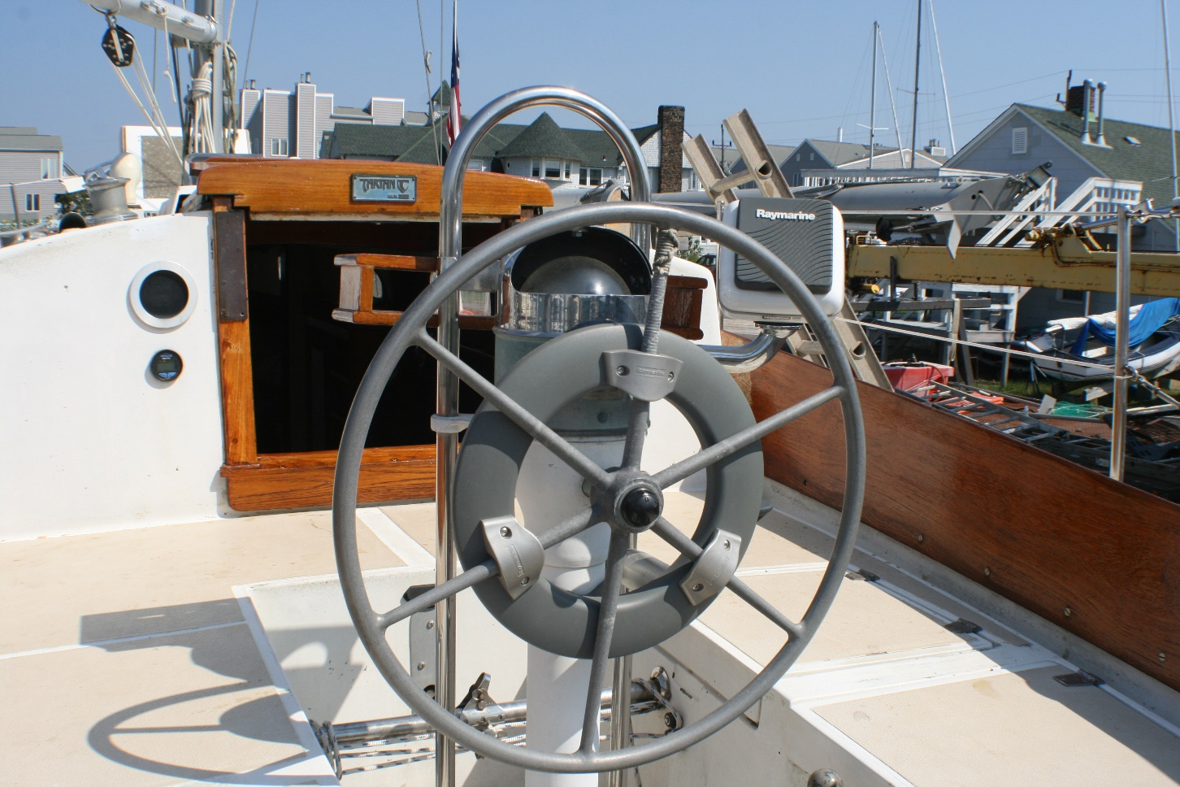

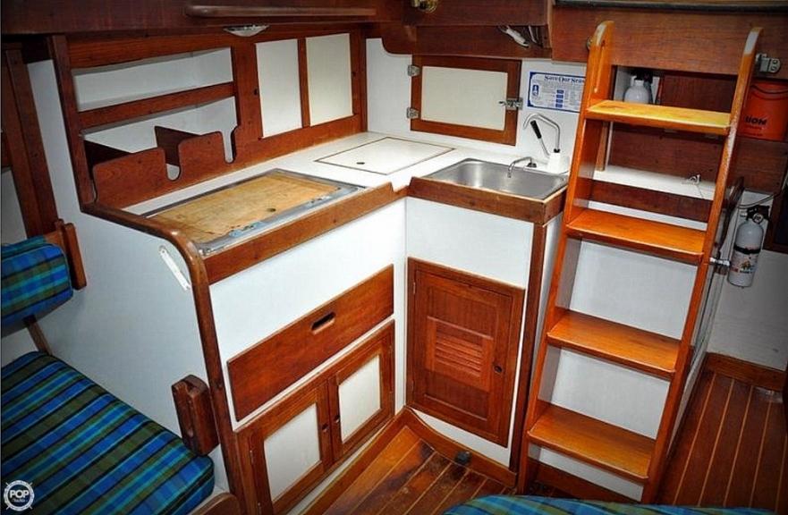
ORIGINAL 1974) Galley - (note the countertop, open bay, and manual sink faucet w/ foot pump)
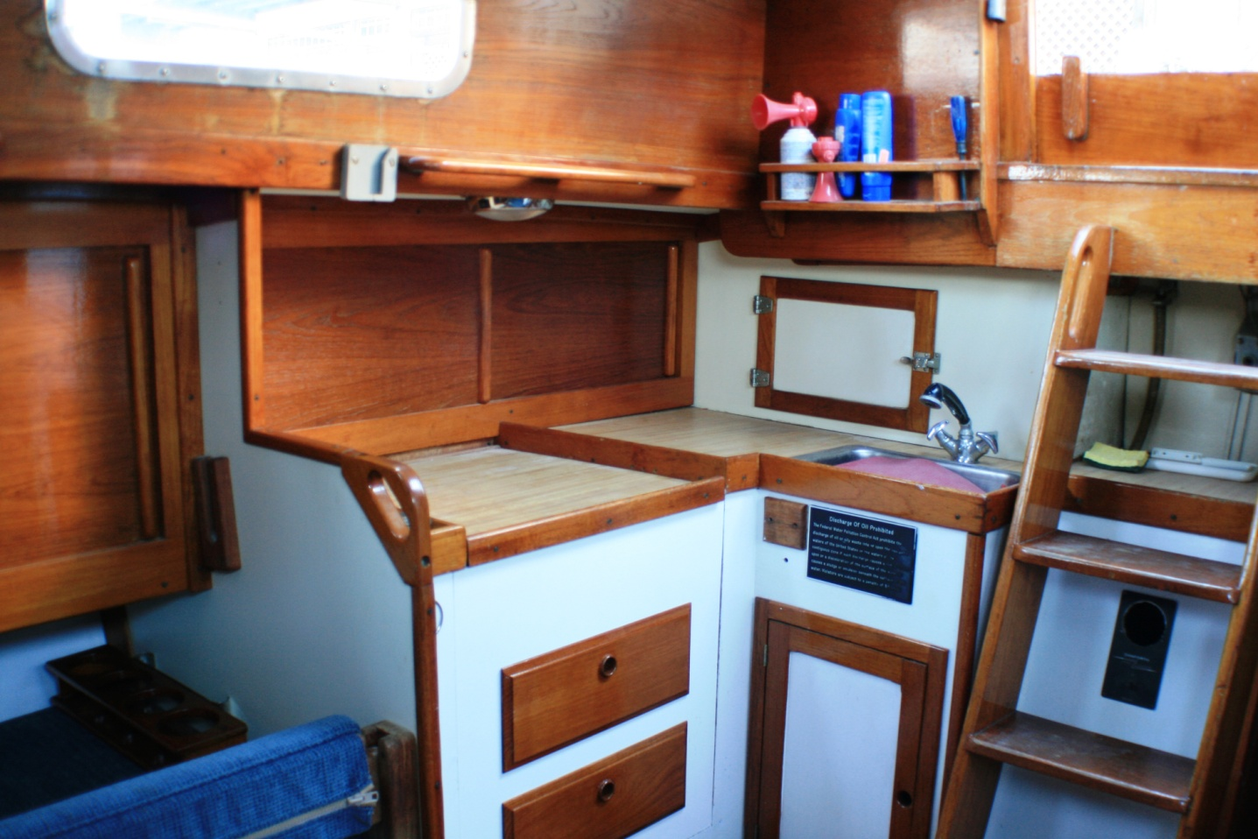
FROLIC’s Present Galley - (note new sliding teak doors, pressure water w/spray hose faucet, and butcher-block counter top)
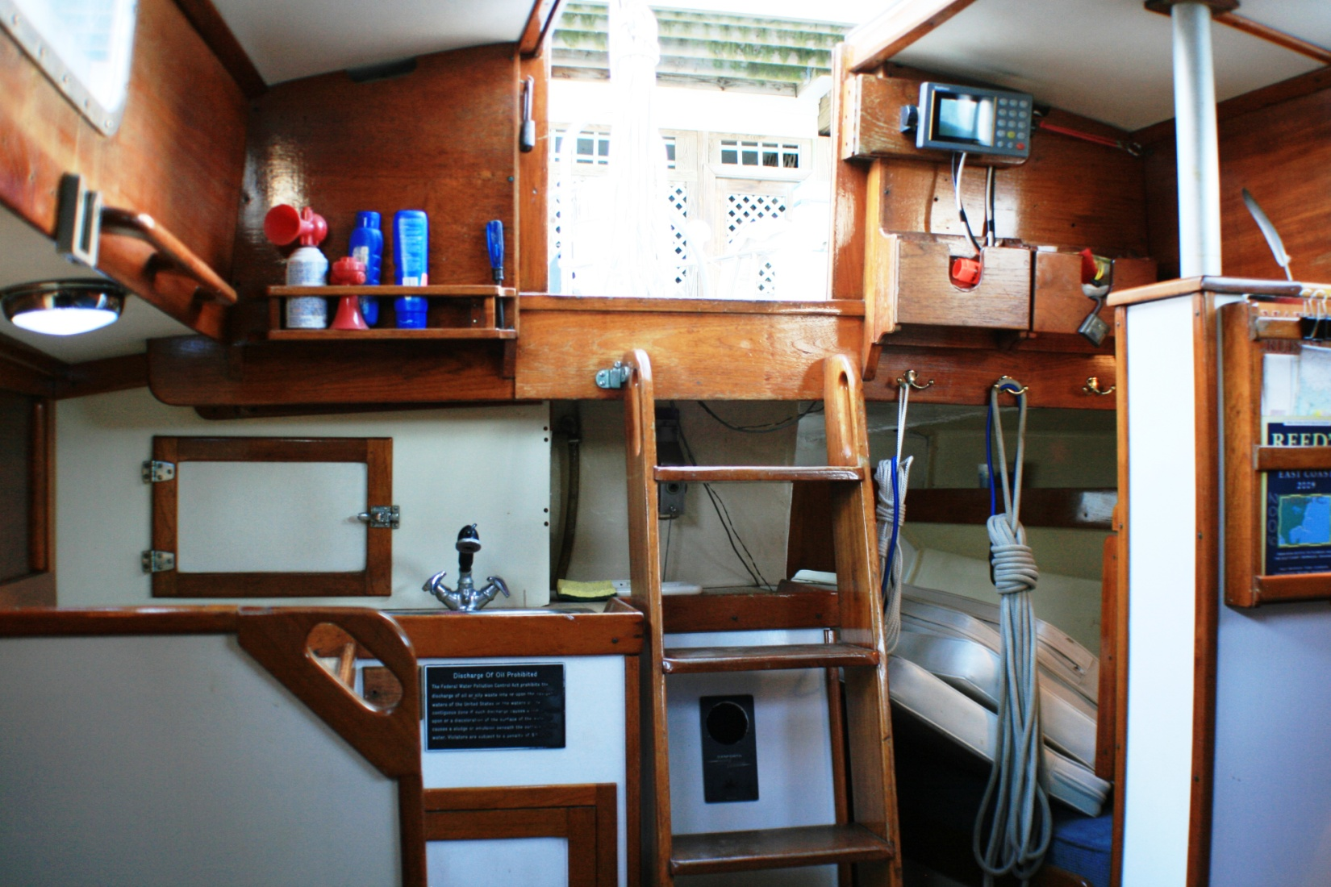
Icebox, companionway & aft quarter-berth (w/ cockpit cushions)
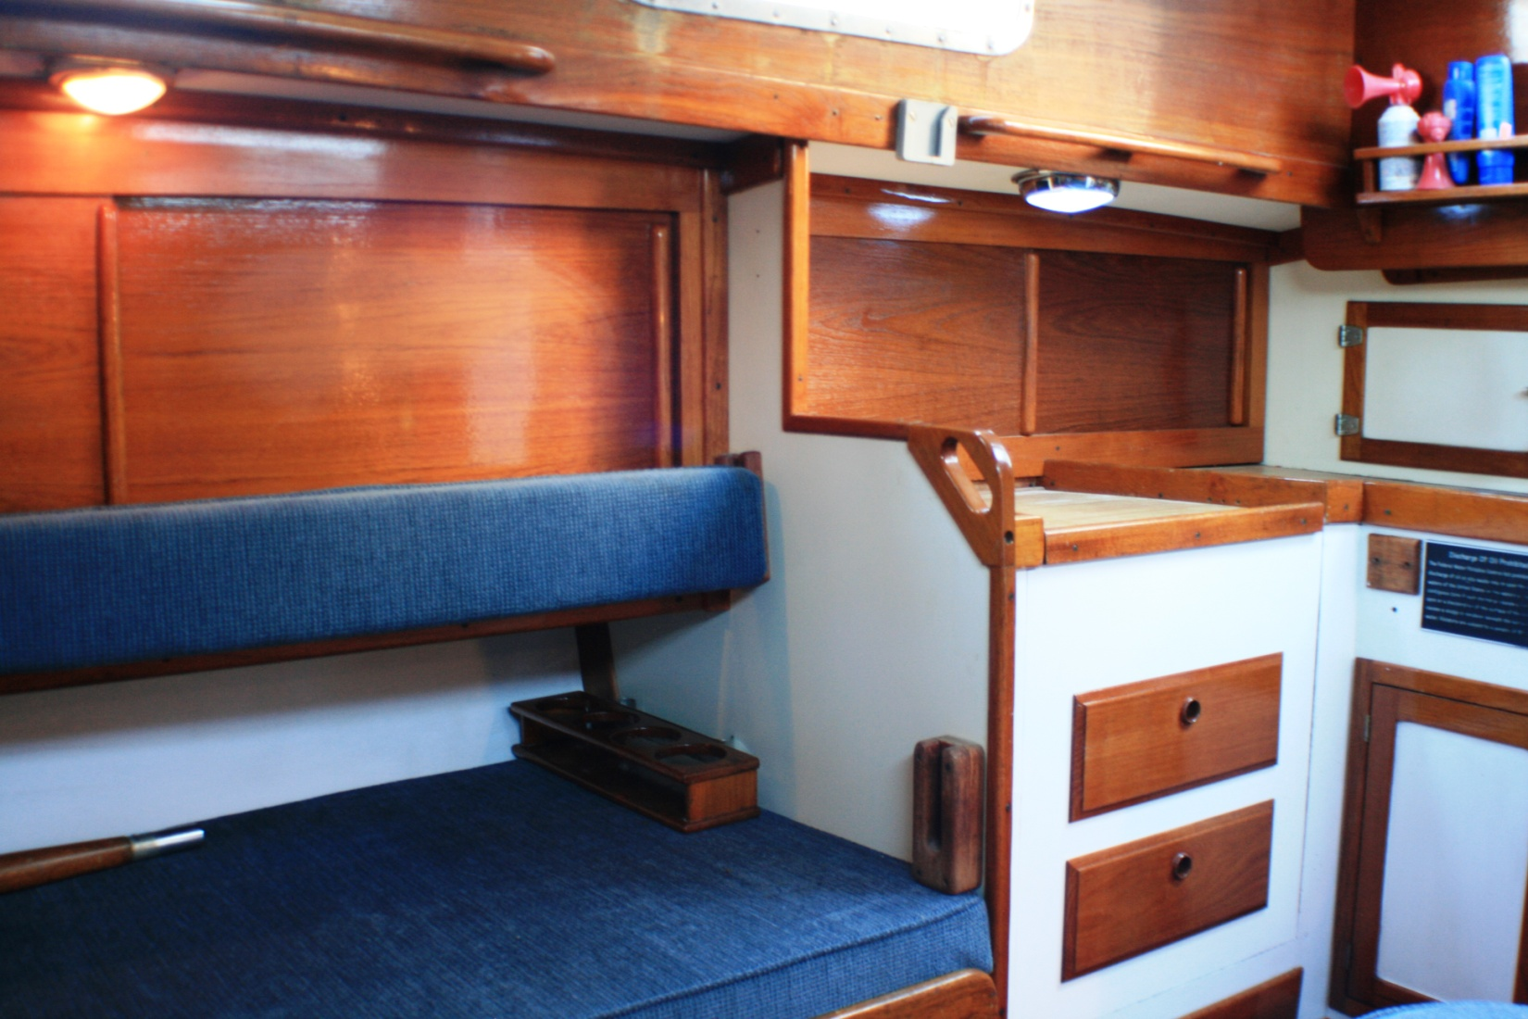
Starboard pilot berth & galley
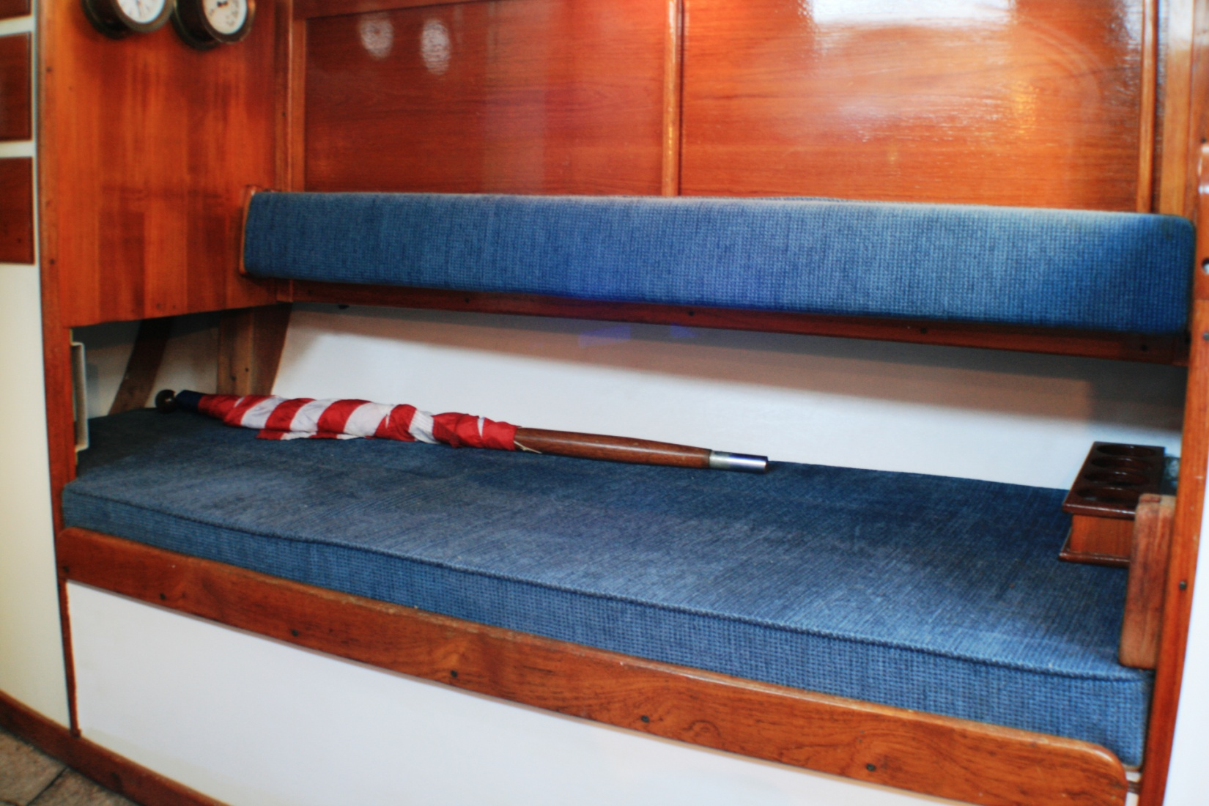
Starboard pilot berth – w/ padded fiddle board
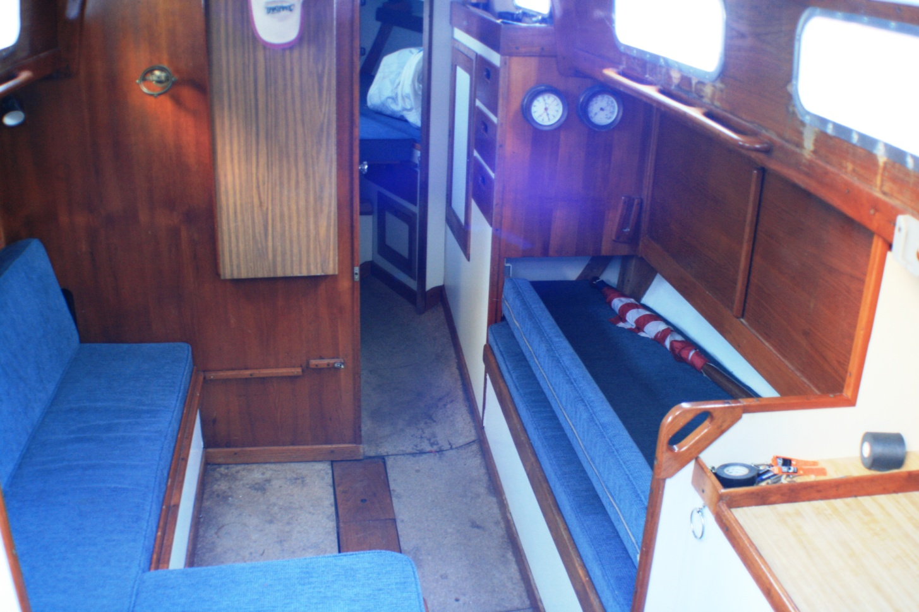
Main cabin - port side settee & double berth, and pilot berth
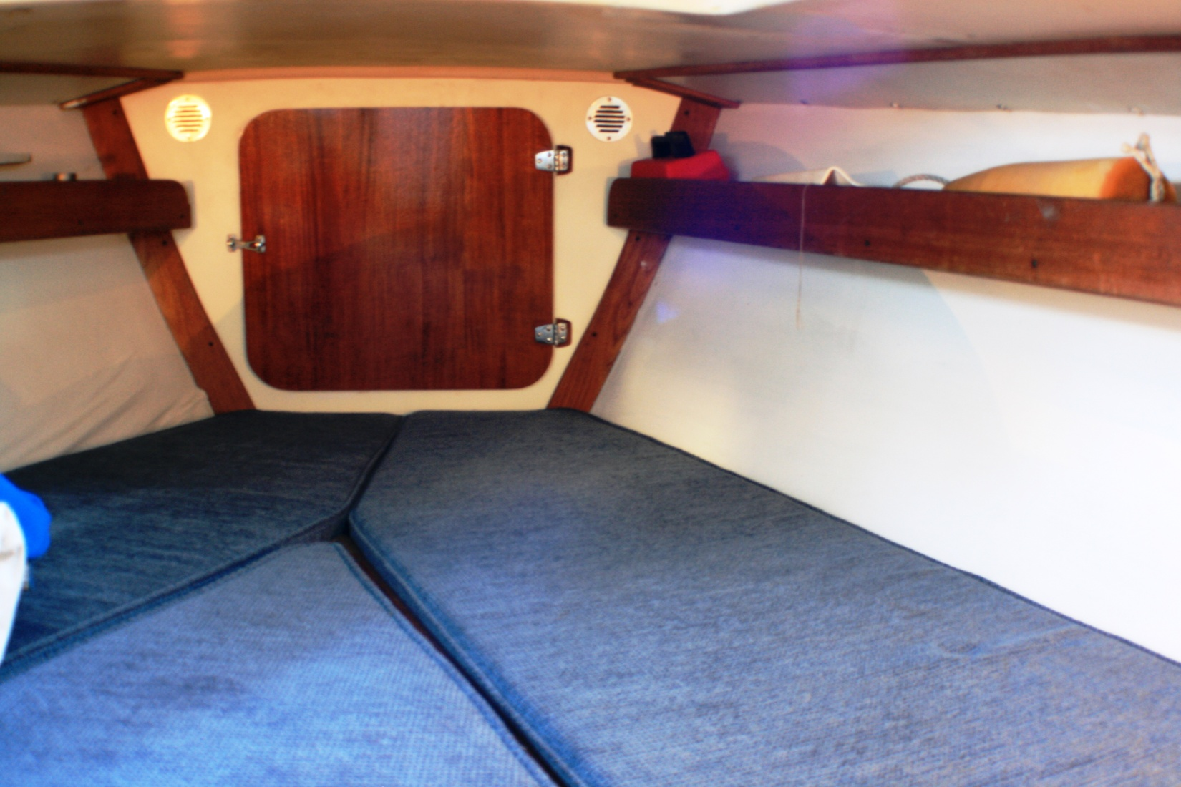
V-berth & anchor locker

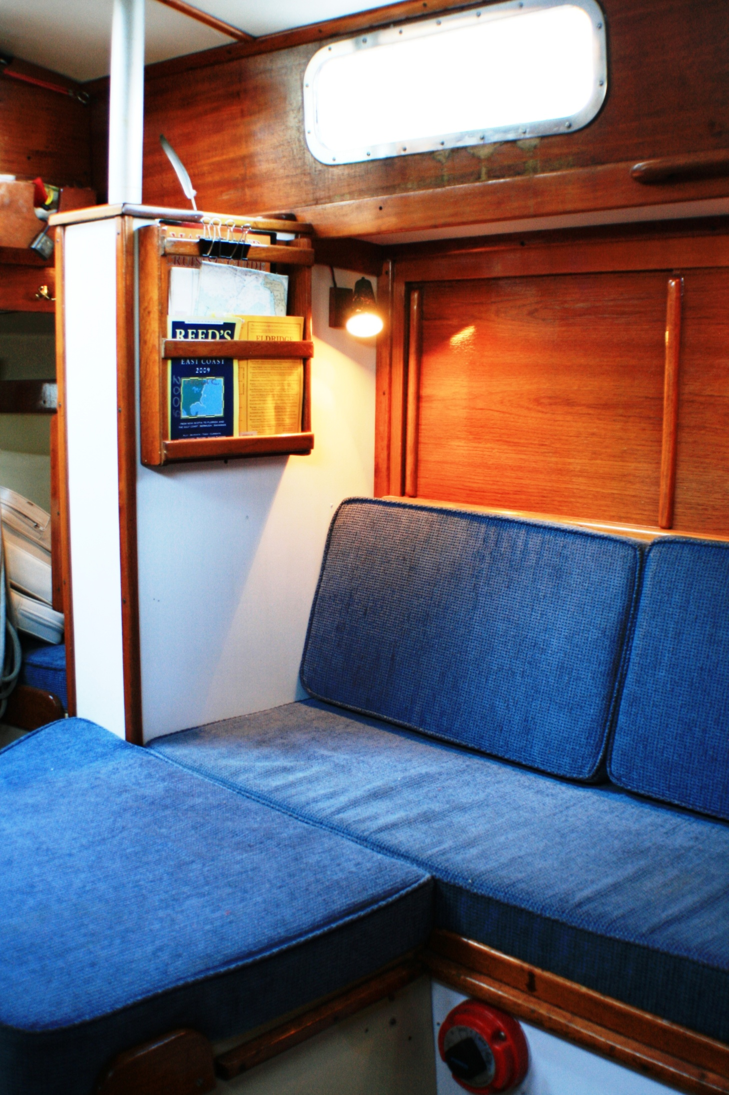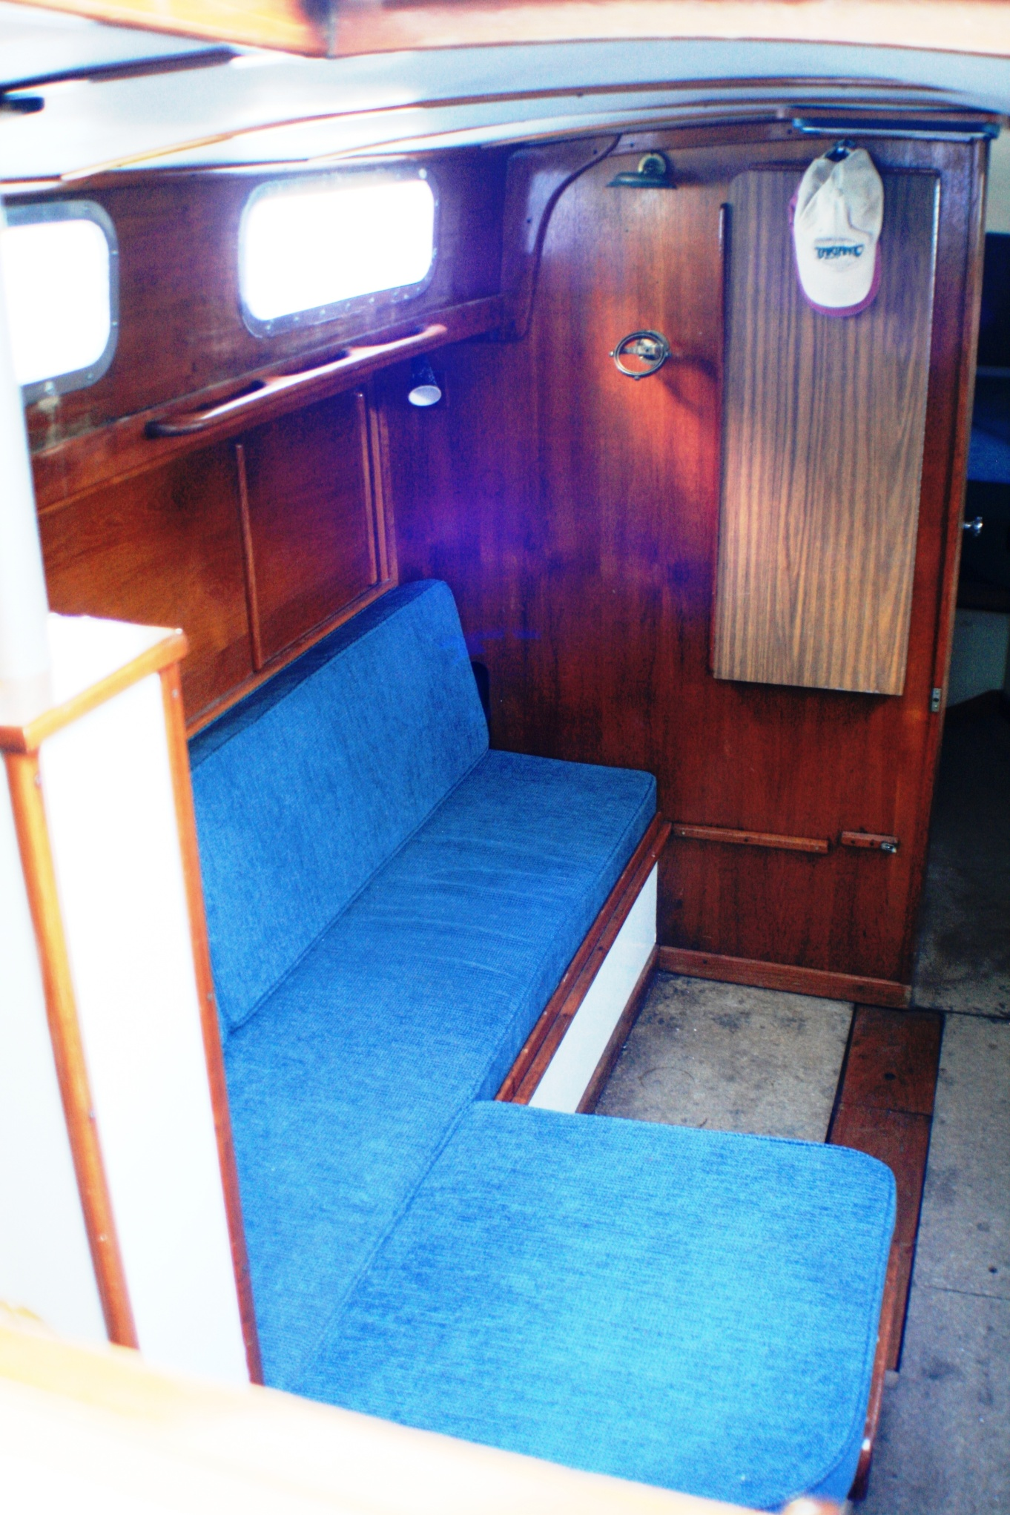
Port-side settee & double berth
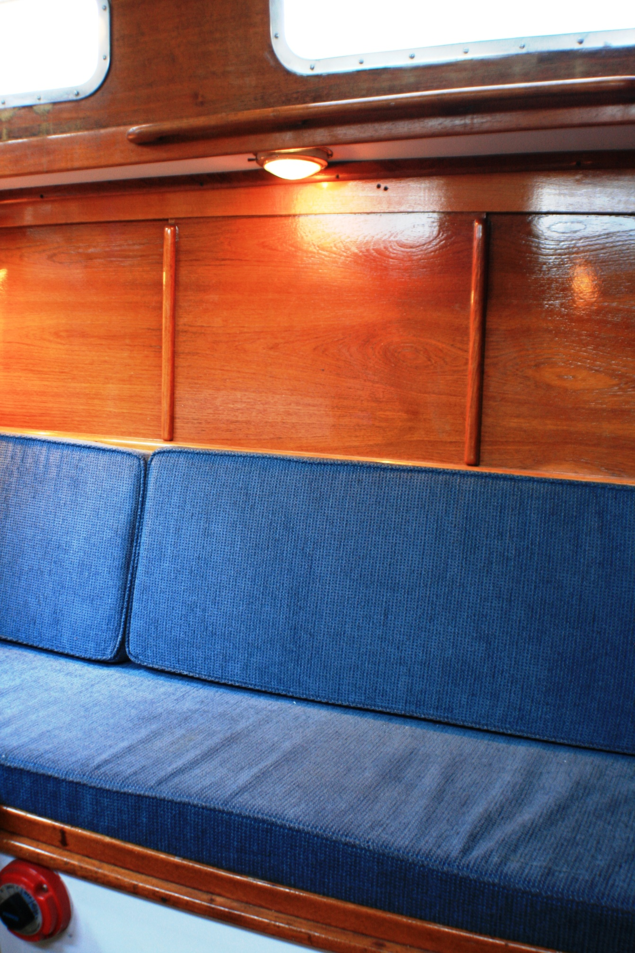
Settee/double berth
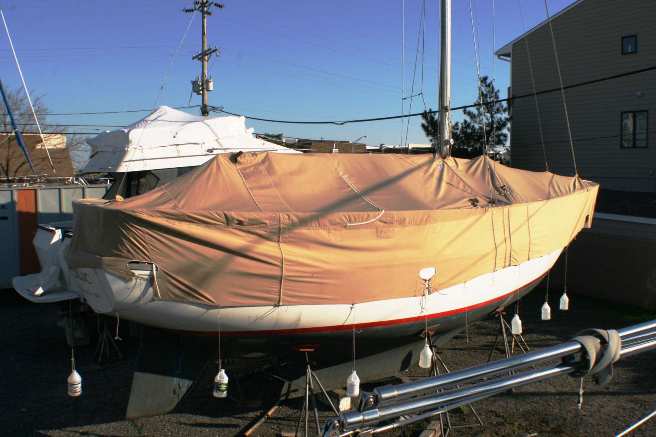
3
1
2
Three-section Sunbrella winter cover
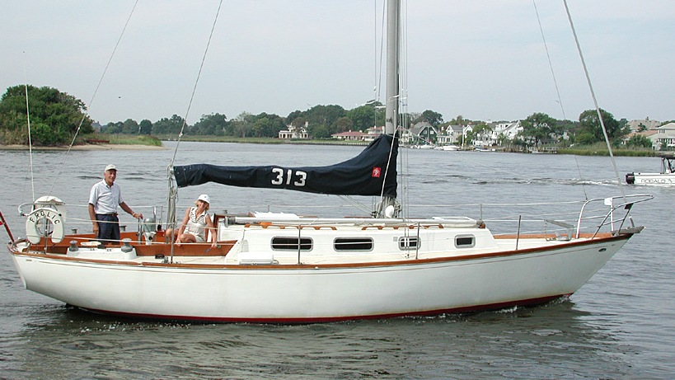
“FROLIC”
~~~~~~~~~~~~~~~~~~~~~~~~~~~~~~~~~~~~~~~~~~~~_/) ~~~~~~~~~~~~~~~~~~~~~~~~~~~~~~~~~~~~~~~~~

